ANA 655 - Database Design for eCommerce Health and Wellness Business

**The Wellness Team**

Students: Aditi Bhujbal, Stefan Francisci, Shila KC, and Jennifer Knight

Project Week 3 Part 2

June 19th 18th, 2022

***Evaluated 2pm Saturday June 18, earned 50***

Based on our previous concept, the Wellness Team is moving forward with our data mart construction. We will explore potential operational sources, explain our ERD diagram, draft our assumptions about business rules, and create a data dictionary.

**EXPLORE OPERATIONAL SOURCES**

We started exploring our operational model with this eCommerce workflow diagram. It shows our basic company structure and details the relationships between our customers and major departments.

[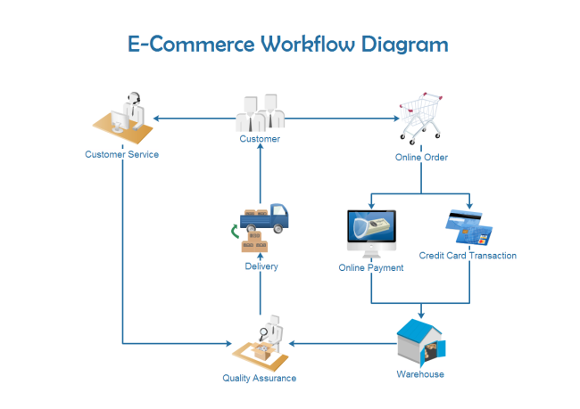](https://www.edrawsoft.com/template-e-commerce-workflow.html)

[Image sourced from edrawsoft.com](https://www.edrawsoft.com/template-e-commerce-workflow.html)

As we can see, when a customer enters our online store, they have two <three> options. They may either create an online order or contact one of our wellness coaches (represented by customer service) who will assist them with any questions they may have and make recommendations to support the customers wellness goals, or they may merely explore options and leave the session with no action.

It is our goal to capture click stream data as well as another source of operational data. With this additional data, we can gain further insight into our website's navigations that result in sales <activity> or lack of page views. Also, information on referring partner links that lead to vendors and suppliers will add additional information on site statistics and customer behaviors. This additional data will yield further insight into customer types, and product performance.

As seen in the image below, events are captured for later analysis by the end users. The information retrieved can then be used for strategic decision making on products or to anticipate future demand.

[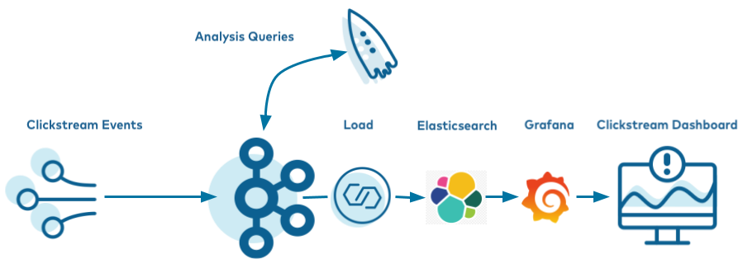](https://docs.confluent.io/platform/current/tutorials/examples/clickstream/docs/index.html)

[Image Sourced from Confluent Developer](https://docs.confluent.io/platform/current/tutorials/examples/clickstream/docs/index.html)

Surveys will be available to help customers figure out what products would work best for them, and quality assurance standards will be used to ensure that our wellness coaches are providing correct information to our customers.

If a customer orders a product, they will provide a debit or credit card, or use PayPal to pay for their <completed> order. Once the payment is approved, the order will be sent to the warehouse, where an employee will examine the product (i.e., check expiration dates on packages and ensure that other products are not damaged) and then the purchased products will be <packaged & > shipped to the customer.

Customer critiques and surveys are a vital part of our company and will be used as a quality assurance method to ensure we are providing a high level of customer service. This will also serve to evaluate the demand and utility for all products. This process ensures that our own warehouses are restocked just in time for future orders to be fulfilled.

The diagram below shows how our Wellness Company will manage social media posts and reviews. This flowchart designates the actions we will take when a customer leaves a critique.

[Image sourced from conceptdraw.com](https://www.conceptdraw.com/How-To-Guide/picture/MARKETING-DIAGRAMS-Social-Media-Response-Online-Store-Social-Media-Response-Flowchart.png)

Customer critiques may be negative or positive. If we receive a negative review, we will determine the reasons behind it and take the approved action. For instance, if a customer is unhappy because they do not understand how the product should be used, we will respond and provide them with the correct product use information. Many of these communications are conducted automatically & electronically.

If the customer is making a suggestion, we will pass the information along to the <internal product manager who may share it with the supplier or > manufacturer <[1]>, or our research and development department. If a customer is asking a question, we will either immediately answer the question and provide support or conduct research to find the answer and then relay the information back to the customer.

If we receive positive feedback from a customer, we will attempt to establish a relationship and, if the customer approves, pass the customer information on to the marketing department in order to create goodwill and promote our business and products.

**ERD OF OPERATIONAL SOURCE & EXPLANATION**

From these initial documents, we created the following <Logical> ERD Diagram using Microsoft Visio.

This model diagram includes two operational kind of information, one for ordering cycle, the other for collecting satisfaction surveys.

|  |
| --- |
|  |

ERD diagram originally created in Visio for ANA650

Authors: Aditi Bhujbal, Stefan Francisci, Shila KC, and Jennifer Knight

Further refinements of the model will be done.

Our <Operational> ERD model consists of 16 tables:

**Table 1: Customer Table**

This table is used to keep track of customer information. Each customer must have a unique customer ID. Each customer will have a first name, last name, gender, and address. <When an order has been placed, a shipping address is provided for business or home address for products to be delivered.>

**Table 2: SurveyResults**

This table is used to collect information on completed surveys so we can better understand our customers' wants and needs. Each survey must have a unique SurveyID. Each survey result will list the survey type, survey subject, survey creation date and status of a survey. It also records which user evaluated the survey. Each survey can be evaluated by one or many users.

**Table 3: SurveyTypes**

This table is used to track and review survey types. Each survey type is unique, and a survey can have only one type (i.e. supplement or exercise evaluation). Keeping track of this information will help us see what products our customers are most interested in.

**Table 4: User Login**

This table keeps track of users. Each user must have a unique UserID. Contractors will have unique user login info. One person may have multiple user login credentials (i.e. if UserID remains idle for more than 90 days, it’ll be deactivated and new ID needs to be created for same contractor).

**Table 5: Roles**

This table keeps track of what the role of a user is. Each RoleID has only one role, but one person may have one or many roles (i.e., a user may have the role of a manager and wellness coach as well). RoleID for each user reveals their relationship with the company (contractor, customer, etc.) and also manages what access they have to information (i.e. they see only product and customer information as a wellness coach, or more detailed business information as a business analyst or a sales manager).

**Table 6: Contractors**

This table is used to manage our contractors’ details. They are required to have a unique identification number, First and Last Name, and department code. Each contractor may have zero or one DeptCodes and each code is unique to a department.

**Table 7: Departments**

This table is used to manage our departments. Each department must have a unique department code and each contractor belongs to zero or one department.

**Table 8: Critiques**

This table is used to manage our customer critiques. Each critique has a unique CritID, but one customer may have many critiques of many different types. This table contains the CritID, CusID, CritType, and CritStatus.

**Table 9: Critique Types**

This table keeps detailed information about each type of critique and the product it refers to. Each critique type is unique (i.e. product critique or contractor critique). There can be multiple types of critiques for one product and customers may have many critiques. This table must contain the critique short description, and may also have a long description if required.

**Table 10: Products**

This table keeps track of our products. Each product code will be unique, product category and product name provide more details about the product. In addition to them, this table must contain the supplier code and product price. (Note: Whenever an order fulfillment detects a shortage of stock on hand, an order from the SUPPLIER’s inventory may be released to complete the order.)

**Table 11: Suppliers**

This table keeps track of our suppliers. Each supplier is identified by a unique code and can supply different products (Note: there may be zero records in **Products** table for a given SuppCode at the stage of supplier onboarding).

**Table 12: Warehouse**

The warehouse table tracks our inventory <for stock on hand, available for order fulfillment>. Each Warehouse has a **WhCode** which is also a primary key, and a product is identified by a foreign key **ProdCode**. <joined to the PRODUCTS table for each product listed in or eCommerce system. > This table also tracks the number of units available.

**Table 13: Purchases**

The purchases table tracks each product and its quantity purchased in every order. There must be at least one record created per order in this table along with the total <payment> amount for a purchased item <summarized if multiple products are itemized on a single order>. (Note, if CUSTOMER does not yet have a shipping address, when an order is fulfilled, a shipping address must be provided.)

**Table 14: CusOrders**

This table tracks customer orders. There is a unique order ID for each transaction and the required information is the customer ID, order date, order status, order status change date, and order total. Each customer may have many orders.

**Table 15: Payments**

This table tracks customer payments. Each payment has a unique payment reference number and requires a payment method and order ID. A date for each payment must be recorded and may coincide with the purchase event.

**Table 16: CusAddress**

This table tracks customer addresses. Each address has a unique ID. However, each customer may have multiple addresses, (such as for place or business, home or for billing or shipping). Also required in this table is the customer zip code.

**BUSINESS RULES ASSUMPTIONS**

* Sales are conducted only through our online store (there are no physical locations) for customer visits for retail purchases.
* Sales are via debit card, credit card or paypal (we do not accept cash).
* All sales are in US dollars.
* Items will be shipped directly from the <internal or suppliers’> warehouse using an outside delivery service (USPS, UPS, FedEx, etc.)
* Sales are complete after the company has received payment and the order is delivered. Thereafter, a set of financial transactions can be transmitted to our financial system.
* All transactions are conducted within North America (we may expand in the future).
* All database transactions shall be noted in Pacific Standard Time.
* Items in their original condition may be returned (by customers) within 30 days for a full refund.
* The inventory on-hand of the warehouse shall be updated when sales or returns are processed.
* Items are sent to customers from the closest warehouse facility.
* Orders will be normally shipped within 2 business days.

**DATA DICTIONARY**

We have created a data dictionary table which can be found at  **<[2]>** [https://studentnu-my.sharepoint.com/:x:/g/personal/**j_knight4630_student_nu_edu**/EYjpfq1-zC1IkOHei3pZih8BBVnBQ2tlEKS5dUWuZg46QA?e=0eI09a](https://studentnu-my.sharepoint.com/:x:/g/personal/j_knight4630_student_nu_edu/EYjpfq1-zC1IkOHei3pZih8BBVnBQ2tlEKS5dUWuZg46QA?e=0eI09a)

We prefer you click to our data dictionary to see it in its original configuration. However, we have included these screenshots for your convenience.

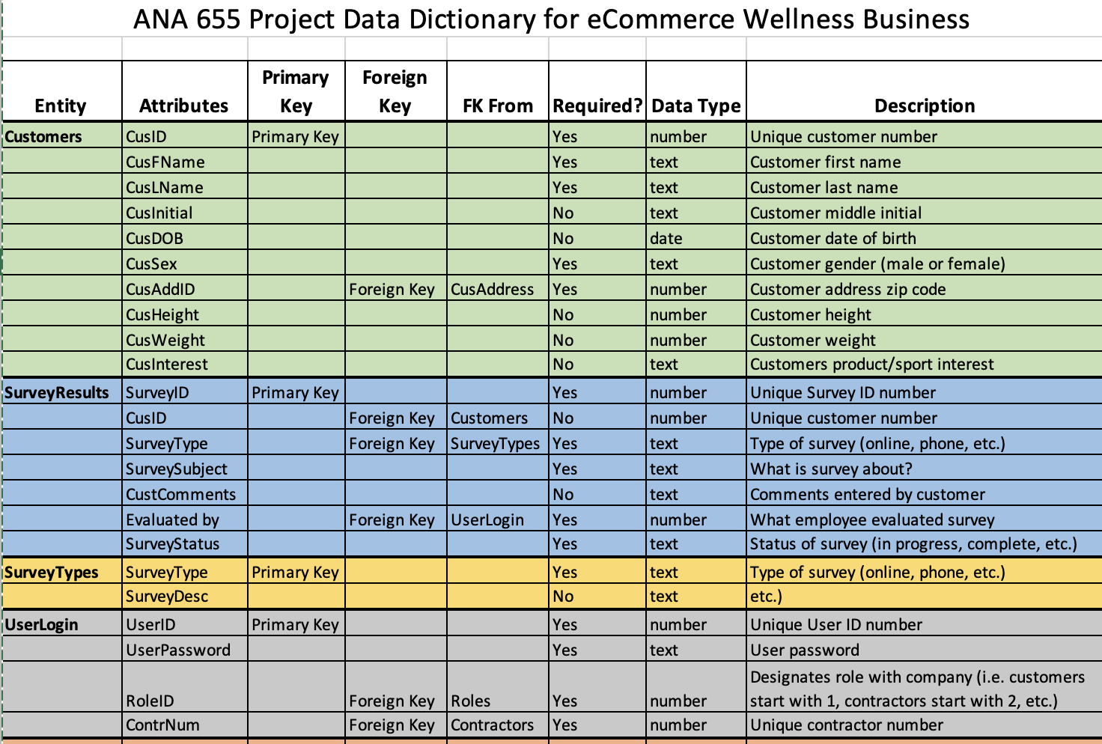

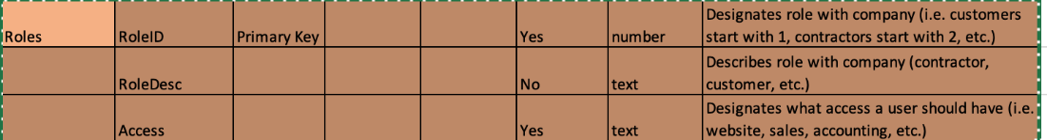

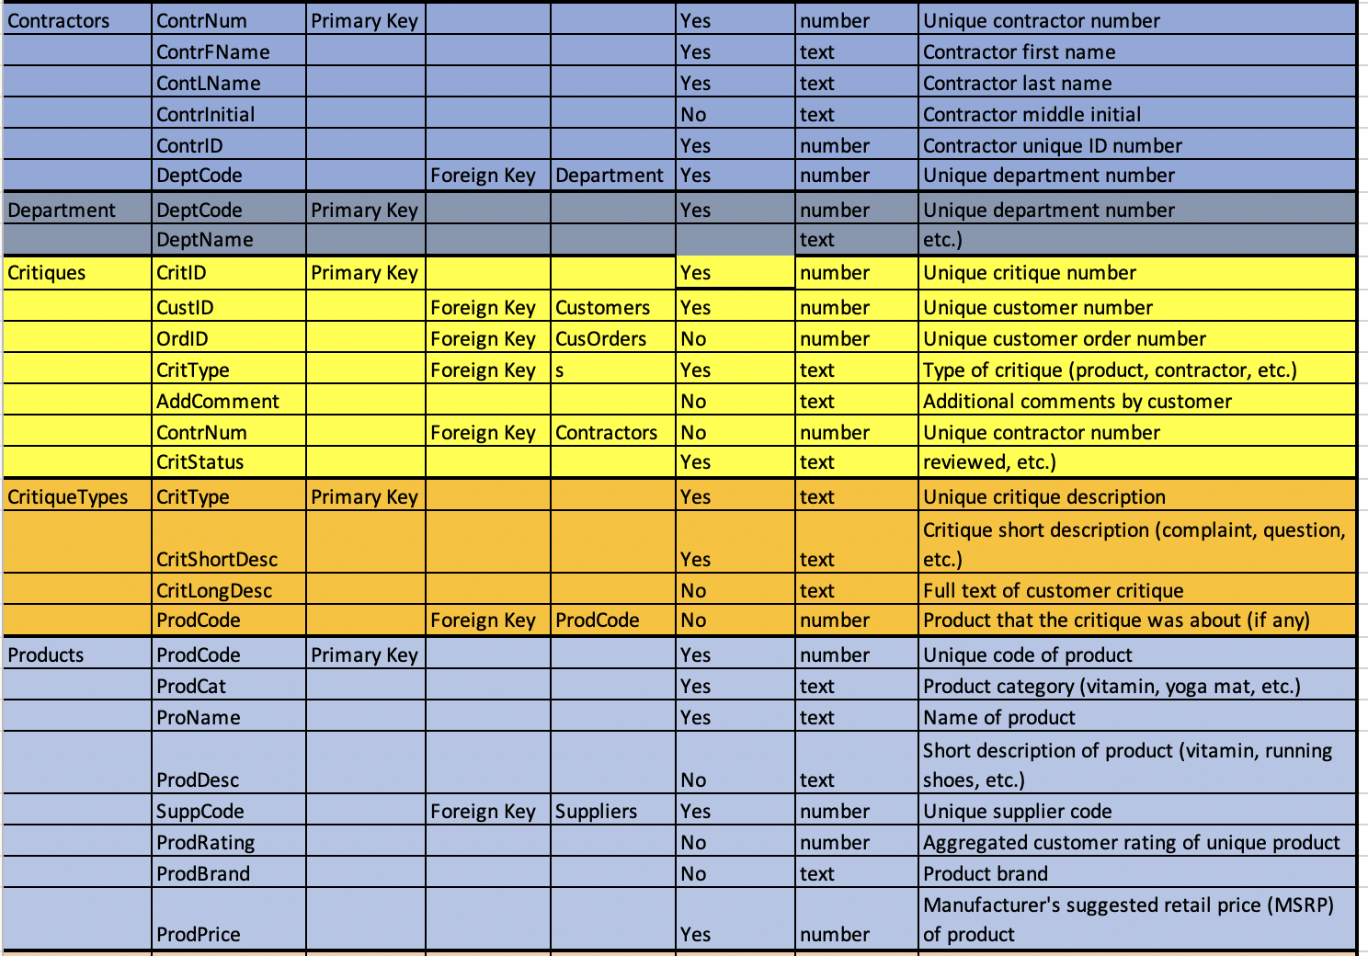

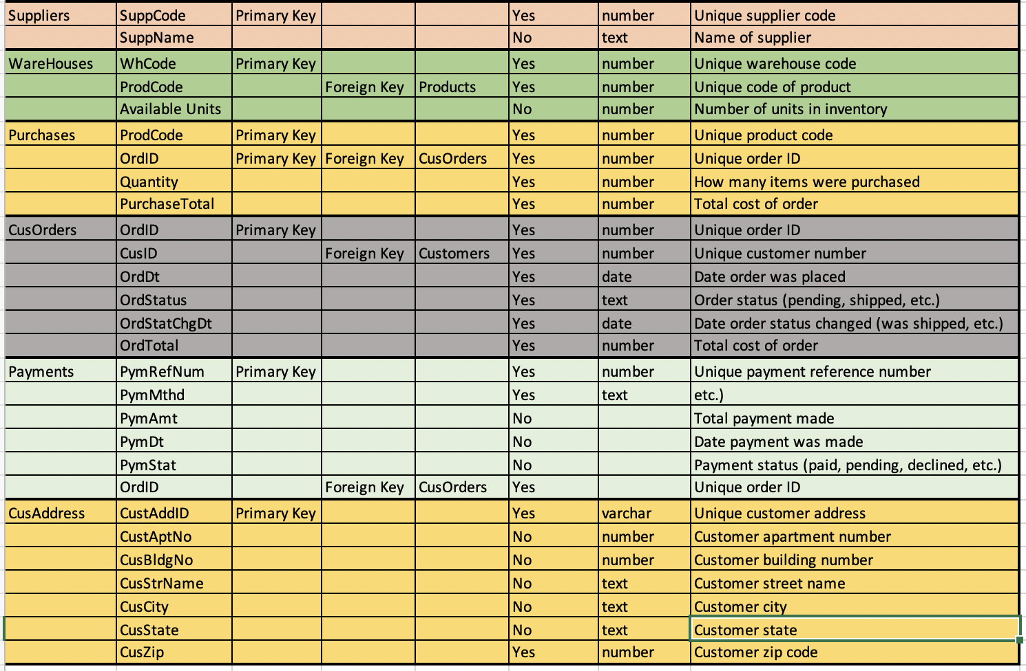

This concludes our Week 3 Part 2 Project. Thank you for your guidance and consideration!

Sincerely,

Team Wellness

References

*Clickstream Data Analysis Pipeline Using ksqlDB | Confluent Documentation*. (n.d.). Docs.confluent.io. <https://docs.confluent.io/platform/current/tutorials/examples/clickstream/docs/index.html>

*E-commerce Workflow | Free E-commerce Workflow Templates*. (n.d.). Www.edrawsoft.com. <https://www.edrawsoft.com/template-e-commerce-workflow.html>

*eCommerce Wellness Business Data Dictionary ANA.xlsx*. (n.d.). Studentnu-My.sharepoint.com. Retrieved June 18, 2022, from [https://studentnu-my.sharepoint.com/:x:/g/personal/j_knight4630_student_nu_edu/EYjpfq1-zC1IkOHei3pZih8BBVnBQ2tlEKS5dUWuZg46QA?e=0eI09a](eCommerce%20Wellness%20Business%20Data%20Dictionary%20ANA.xlsx.%20(n.d.).%20Studentnu-My.sharepoint.com.%20Retrieved%20June%2018,%202022,%20from%20https:/studentnu-my.sharepoint.com/:x:/g/personal/j_knight4630_student_nu_edu/EYjpfq1-zC1IkOHei3pZih8BBVnBQ2tlEKS5dUWuZg46QA?e=0eI09a%20%20‌)

*How to Create a Social Media DFD Flowchart | Social Media Response DFD Flowcharts - diagramming software| Social Media Response | Media Flow Chart*. (n.d.). <Https://Www.conceptdraw.com> Retrieved June 18, 2022, from <https://www.conceptdraw.com/examples/media-flow-chart>

1. My assumption is that a manufacturer is the original source of a product (provided in bulk or prepackaged ready for shipping) but who is not normally an entity with a login direct connection to the internal operational databases.
2. This link does open a file that resembles a spreadsheet… which I suggest that it should be exported into Excel so that another tool (perhaps Power BI) can read it. I did notice that size of each field is missing.